|  |  |
| --- | --- |
| Description | Class\Enum |
| (class)Entry point of the EXE | Program |
| (class)holds logic between Garage and user | UIManager |
| (class)holds tools to communicate with user and basic validation | Utils |
| (class)manages a dictionary of ArgumentWrappers | ArgumentsCollection |
| (class) sent to the user to get the desired property data | ArgumenWrapper |
| (class)object that represents the electric vehicle motor | Battery |
| (class)exception for charging electric motor | BatteryMaxWorkingHoursException |
| (class)object that represents the car type of vehicle | Car |
| (class)object that manages the garage and is the bridge between the UI and the vehicle factory | Garage |
| (class)a object that hold information about the vehicle owner and vehicle license plate number | GarageTicket |
| (class) object that represents the gasoline vehicle motor | GasolineTank |
| (class) Used by Vehicle Factory, it creates an object for Motor entity used by the Vehicle Class | EnergyContainer |
| (class) Used for inheritance for to create a 'kind of' Energy Container that aggregates the energy data related with a Vehicle's Motor object | Motor |
| (class) object that represents the motorcycle type of vehicle | Motorcycle |
| (class) object that represents the truck type of vehicle | Truck |
| (class)exception that represents the value that the user chose above or below the accepted amount | ValueOutOfRangeException |
| (class)base class for all types of vehicles and hold base properties for all of them | Vehicle |
| (class) manages and builds the vehicles as requested from the arguments the user delivered to the garage | VehicleFactory |
| (class)object that holds the properties for wheel | Wheel |
| Holds the keys for the float max const dictionary | eVehicleMaxConstantTypes |
| Holds the type of supported vehicls that the factory can currently produce | eSupportedVehicles |
| Holds the type of supported engines that the factory can currently produce | eMotorType |
| All supported energy types | eEnergyTypes |
| Supported gasoline types of choice for gasoline type engine | eGasolineTypes |
| Supported color type for car type vehicle | eCarColors |
| Supported number of doors for car type vehicle | eNumberOfCarDoors |
| Keys for argument dictionary to precisely receive the desired data | eArgumentKeys |
| In garage ticket status of the vehicle in the garage | eTicketStatus |
| All the otions of the menu options | eMainMenuOptions |
| Motorcycle license type for user to choose from | eLicenseType |

vehicle inheritance

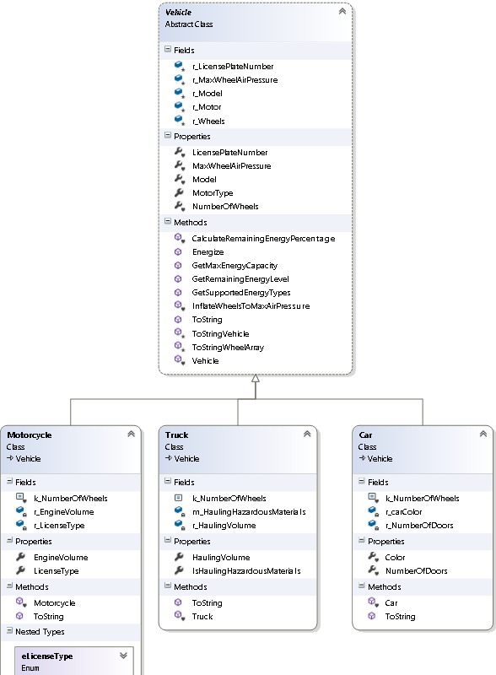

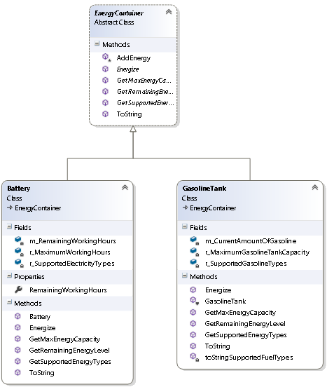 Engine inheritance